**ABBEY NETBALL CLUB AGM**

**ONLINE**

**Annual Reports for 2019 - 2020 Season**

**SUMMARY REPORT – CHAIR JO DAVIES**

Hello all Abbey members & Parent/Guardians

Well this is unprecedented, also an unusual introduction to the Abbey AGM which is being sent to you online. As you are aware we have cancelled our Annual AGM and Awards night due to the Coronavirus. Never in my lifetime has ALL netball had to stop from Grassroots to International level. If Covid 19 has affected you/your family, I hope you have recovered and if you have lost a family member/friend, our hearts go out to you and your loved ones. We have Abbey members/parents who are NHS Workers, Key Workers, Carers, Volunteers etc. We are truly very proud of you and the dangers you have put yourself into helping others.

**GENERAL**

Our club is increasing each year and I’d like to thank all the committee members for the innovative ideas of how we can keep this club a success taken into account all the new training sessions, health & safety policies, GDPR, finances, socials, social media and Engage to name a few.

Your committee has worked tirelessly over the past year, Winter Trials, Coaching, Sports Hall Bookings, Monitoring and acting on emails into the Abbey Account, Minutes, Junior Umpiring Schedule, Christmas Meal, Junior Coaching & Matches, Senior Summer Teams and of course this AGM. On top of that and most importantly is collecting in the monies.

The new ENgage membership process was launched in August 2019 and Mike Buffham our Treasurer was part of the steering committee to help All England launch this system. Thank goodness for Mike, because he has managed to guide us and ensure we have linked ourselves to Abbey and each member is correctly affiliated. This needs to be renewed in August 2020 by all members, but hopefully you are rehearsed in completing this task again! Mike thank you for all your time given to Abbey keeping us up to speed with payments etc.

Ideally, I would like to see more people take on bite-size responsibilities within the junior and senior teams as this will lessen the load on the coaches, captains and committee. Therefore, please ask yourself as players and parents, what can I bring to the table? We have lots of small jobs at matches, tournaments and club nights that we need help with. Please offer your services where you can eg, washing bibs, putting the equipment away after matches/training, organising a team social within your team etc. Its good to get involved.

Commitment – Please consider your commitment to matches and club nights. Coaches plan training around teams working together for their matches. It really needs players to turn up to make this work and for teams to get the right result in their matches, which ultimately is a win.

Junior Coaches – We have some fantastic coaches in Abbey, who work tirelessly with the players also keeping you players/parents/guardians up to speed with training/matches and tournaments. They keep up with Coaching techniques and levels, legislation, first aid courses, safeguarding, umpiring and some also play themselves. They are in my book, Wonder Women! Our thanks to Jo Pearce (Junior Co-ordinator), Kerry Smith, Drew Murray-Gill, Rose Hodgson, Ella Thompson, Sue Lyons & Kate Ricks.

Senior Coaching – Overseen by Tash Vickers, with assistance from Kate Ricks, Lee-Anne Walker and Kirsty Heath. Thank you for your motivation, skills and effort given to Abbey.

The players do really appreciate your work. We did manage to have a couple of sessions taken by Trish Kilczynski who is very experienced and coaches for Mavericks and other establishments, unfortunately we were unable to maintain a regular programme due to her other commitments.

Drew Murray-Gill: Drew joined our club January 2019. Her input to Abbey has been invaluable, coaching Lightning & Storm, plus attending their matches on Monday and Wednesday nights. Drew has also taken on the U15 coaching. Drew thank you for all your input at Abbey from myself, the Committee and the players. Your coaching and enthusiasm has enormously benefited all the players and I hope it’s helping with your degree too.

Lastly a big thank you for Rose Hodgson and Sukey McMaster who spent lots of time in arranging the venue/drinks/awards etc, only for it all to be cancelled. They deserve a big round of applause.

We will announce the winners of the various awards in this report.

**A FEW STATS RELATING TO THIS SEASON**

|  |  |
| --- | --- |
| **Members** | **Total for 2019/2020 Season** |
| Senior Members (age 18-70+ years) | 53 |
| Junior Members (age 8 – 17 years) | 141 |
| Senior Coaches | 4 |
| Junior Coaches | 7 |
| Committee Members | 13 |
| Senior Captains | 5 |
| Junior Captains | 8 |
| Total of Senior Goals Scored | 4478 |
| Total of Senior Goals Against | 4409 |
| Total of Junior Goals Scored | 1657 |
| Total of Junior Goals Against | 1639 |
| Total of Senior Matches Played & Umpired | 123 |
| Total of Junior Matches Played & Umpired | 105 |
| Total of Senior Minutes Played & Umpired | 7380 |
| Total of Junior Minutes Played & Umpired | 4200 |
| Average Senior Goals per Match including oppositions | 72 |
| Average Junior Goals per Match including oppositions | 31 |
| An umpire makes approx. 22800 decisions per match x 123 Senior matches | 2,804,400 |

**Only includes Abbey teams and excludes tournaments**

**PERFORMANCE**

* Increased membership across the whole club
* Emma Thacker – Abbey Junior has been playing England U17 Squad
* 5th team entered in Summer 2019 League.
* 5th team entered in Winter Prem Plus League named Blizzard. This was to encourage players who did not get as many quarters in the SR team plus other senior members. However, this has presented some issues during the season and will be reviewed.
* Bronze CAPs awarded October 2018 and lasts 4 years. Thanks to Kirsty Heath, Sue Lyons, Kate Ricks and Lesley Williams.
* Toilet Roll Challenge – Due to Covid 19 as all training and matches were temporarily ceased, we did manage to put together a Toilet Roll/Netball Challenge. Thank you to those that participated.

**COACHING**

* 4 Level 1 coaches at Abbey and a couple of trainee coaches coming through the system
* 5 Level 2 coaches at Abbey
* Tash Watson (Senior Coach) delivered sessions for the SR & Prem Plus Teams.
* Drew Murray-Gill coached Lightning & Storm.
* Junior Coaches and Assistants have been arranged for next season.
* U11 training group has proved very successful. Will be training every week due to large numbers.

**RECRUITMENT OF PLAYERS AND COACHES**

* Introduction of taster session for regional players and older juniors was organised for 20 May 2020 at Rye but is postponed until further notice.
* We are still on the hunt for a Senior Coach for Hurricanes and Prem Plus.

**THANK YOUS**

* We are an amateur club with hardworking committee members, coaches, umpires, administrators etc who all have families and work commitments to cope with too.
* Smooth organisation of correspondence – Thank you Sukey who monitors the email account and all admin. It can be a relentless task especially beginning of the season. Without you we’d be stuffed!
* My Vice Chair – Kate Ricks, always in the background giving me support along with helping Hurricanes.
* Strong commitment from volunteers, especially parents/players partners.
* Safeguarding, DBS, GDPR and registers all up to date thanks to Lesley Williams
* Hall Bookings – Thanks to our Bookings Secretary Becky Mailen who has ensured all slots are booked and reconciled for the Juniors and Seniors across Rye St Antony and Headington School.
* All Players, without you this wouldn’t be possible. Thank you for choosing Abbey.
* Parents of Juniors, without your encouragement the girls wouldn’t be here today. We appreciate your commitment along with your daughters, ensuring they turn up to training and matches regularly.
* Senior Coaches – Your hardwork does not go unnoticed. You make it fun and keep us all fit and feisty!
* Junior Coaches – Your commitment to the girls and keeping parents informed is phenomenal.
* Committee – I think you are all fantastic and I really appreciate all you do and in your spare time too.
* Captains/Coaches – Thankless task, but we all totally appreciate you and so do your players.

**FOCUS FOR 2020-2021**

* Update Abbey Website (anyone willing to help take on this task?)
* Introduce new netball dresses for Seniors TBC
* Introduce new netball dresses for Juniors 2021-2022
* Higher training attendance across all senior teams
* Coach for SR & Prem Plus Teams
* More members to take Safeguarding courses.

**CORRESPONDENCE SECRETARYS REPORT – Sukey McMaster**

This year started with a bang with the changes in the affiliation process with England Netball moving to an individually generated membership. Thank you all of the Abbey members for persisting with this process and for your patience.

It was notable this year that there are more documents required by England Netball and ONL in order to get our Senior and Junior players ready for training and match play. By the start of the winter season 2020/21 the aim is to simplify the paperwork and reduce the email traffic between the players and the club. We will however still need paper copies of the registration forms, so we ask that all club members remember this at the start of September.

I would like to thank Jo Davies for her support in this first year of taking over the secretary responsibilities and for everyone’s patience during the enormous amounts of email traffic that took place last August, all a distant memory now!

**TREASURERS REPORT – Mike Buffham**

This report covers the clubs accounts for the year August 2018 to July 2019 and a review of the activity in the period from August 2019 to the end of March 2020.

The accounts for the year end 31 July 2019 show an income of £26,148 and an expenditure of £24,645 resulting in a surplus of £1,502.71 for the year. The income decline is attributable to the reduced income from Junior memberships (collected in June/July 2019 for the 2019-20 season) due to the change in EN membership process which is now the responsibility of the individual player rather than the club. This contributed to a reduction of membership income in the year of £3,823 which will come through as a reduction in EN membership costs in the 2019-20 accounts.

There were 2 other major changes in income in this financial year. Firstly, senior match fee’s, which increased by £2,282, as the club changed to collecting match fees in advance (payable to the club) rather than on a match by match basis to the team captain as in previous years. This was done to remove the administrative burden from the club captains on and after match days also to smooth the process for paying senior umpiring costs and travel costs for Southern Regional matches. Secondly the kit income fell by £1,212 largely as senior players waited for new kit that arrived in the 2019-20 season.

Expenditure increased in the year, in many cases due to changes in the way we managed some of our netballing costs. Most notably EN affiliations were up £986 as a result of increased club membership, league and tournament entries costs increased by £1,773 although part of this was offset by reduced junior match court costs of £1,097 as the league now collect this in the league entry fee. Senior umpiring fee’s and travel costs increased by £720 and £303 respectively, again offset by the change in the way we collected match fee’s in advance (see income). Other expenditure included £506 of membership refunds agreed during the year (largely due to serious injury or other reasons approved by the committee) and committee membership discounts of £387.

Also, of note was the significant reduction in the cost of the awards night by moving the event to St Johns and negotiating much more favourable rates on venue hire and drinks, thanks must go to Rose Hodgson for the work she put into this reduction in expenditure.

Many of the changes in income and expenditure above were driven by a desire to make the club slightly easier to administer and allow players, particularly captains, to focus on the netball as much as we can. Overall, our cash position improved by £1,506 in the year, which, coincidently, is exactly the balance we hold in our contingency account, with our current account balance being £12,241 at year end.

I think it is particularly pleasing to see that we have maintained the increased netballing activities we reported in the prior year and improved our cash position at the same time. We are currently (at the end of March) 8 months through the August 2019 to July 2020 year and have income of £10,995 against a plan of £19,400 and expenditure of £17,793 against a plan of £22,200.

As I write these notes, we are clearly in a time of great uncertainty which is spreading far beyond the world of netball and we, regrettably have to assume there will be no more netball matches or events this season which is a great shame for all of us. This will have a small impact on our financial performance most notably in terms of no income or expenditure being made for our AGM. Our income plan for this year will be impacted by the decision we still have to take in terms of whether we collect junior memberships in June / July as we have done in the previous 2 years on in August (our next financial year). This decision will almost certainly be guided by external events this year. I do need to also mention that we did get through the switch to the new ENgage membership process largely unscathed this year and I must thank all players and parents for their patience as we overcame some early teething problems, but I think we are now in a good place as we all start to think about renewing our EN memberships for 2020-21 !!

So overall our finances remain in a similar position to last year, although we will need to consider the strength of our cash position to ensure we can absorb any significant changes in our plans in the future either through changes in our membership (up or down) or external impacts on the timing of our income.

See attached Profit & Loss Sheet to this document.

**UMPIRING REPORT – Jo Davies**

This year we saw a fundamental change in the way our Senior & Junior matches are umpired and organised. The ONDB (Oxfordshire Netball Development Board) has taken over the organisation of umpires in both senior and junior leagues. We still need to encourage and promote umpiring within Abbey, but I no longer sort out the dates/matches. The ONDB are covering all matches with experienced umpires and trainees. Each trainee has a mentor and they attend all the matches the trainee is umpiring. I have been involved with a little bit of mentoring and was about to sign up to the Mentor Workshops before all netball had to stop. Oxfordshire are at the forefront of promoting umpiring and this is being adopted by other counties. Within our own club, we have the following:

*Sue Lyons is training for her Level B Umpiring Award

*5 Juniors signed up with the Umpiring Academy, unfortunately this was cancelled due to the Coronavirus

*ONDB coach and mentor trainee umpires. If you are interested in picking up the whistle please contact me through the Abbey email account. It will build your confidence, give you a better understanding of the game and apparently a good CV point!

**VOLUNTEERS REPORT – Gemma Muttit**

Thank you very much to all the volunteers within the club for another year of selfless hard work. Thank you to the umpires, scorers, timers, primary careers, team managers, coaches, captains, committee members and supporters within the senior and junior section of the club. Without these people the club wouldn’t be able to run and we are all extremely grateful. This has allowed us to spread the load within the club across more members and it was fantastic to see some new faces contributing and getting involved this

It is therefore crucial that we find members of the club to fill the committee for next year to ensure the club can continue to run, and the same opportunities can be provided. Our club survives on people offering their time and support to see the club succeed year after year and it is very rewarding. Whatever role, big or small, you would be greatly appreciated and can find something to suit you. There is also a possibility we could support and provide training opportunities for coaching or umpiring too. Don’t sit back and wait for somebody else to volunteer, we need you!

**SOCIAL MEDIA REPORT – Lauren Davies**

We have been more prominent on Instagram and Facebook this season. Thank you to the players/captains who pass on the team photos and short reports, whether it’s a win or a loss. Its good to keep Abbey regularly featuring on social media. It also keeps club players in touch with those players they do not see at training. It helps us come together. Hopefully it will encourage new players to the club too.

**CAPS (Club Action Planning Scheme) & SAFEGUARDING OFFICER – Lesley Williams**

Our CAPS Bronze re-accreditation was awarded in November 2018 and lasts until November 2022. *An annual 'Health Check' must be submitted to England Netball (to be finalized).*

We are proud of our club, its established systems and procedures with oversight for all its members and its recognised friendliness.

Safeguarding is everyone's responsibility....  it requires us *all*to be aware of safety and wellbeing in its broadest physical and mental sense, for all members, but particularly for our young people, under 18.

The collection of signed registration forms including the club code of conduct, commitment statement and emergency contact details, at the start of the winter season and then from new members arriving during the year was generally successful this year. However, the committee  is discussing the possibility of an online submission.  The health and emergency contact information from these forms must be available for reference at all clubnights and matches and that currently means copies of the forms.  We expect to initiate a new whole club system to capture the necessary information in line with the GDPR regulations so that all personal records are held and used securely.

We maintain the weekly Clubnight registration system for juniors and seniors.

Lead coaches are required to take the sports specific 'Safeguarding and protecting children' and First Aid Training courses; the former is available online so others could easily take it.  I am the named Club Safeguarding Officer but am not regularly at junior training so rely on *Assistant CSOs.* An action for the coming months, ready for the 2019-200 season.

All our junior coaches have a DBS safeguarding check and have attended safeguarding training.  But, with such a large club and with U18s playing in senior teams (and U16s in the summer), in order to be consistently safe, we encourage more members to be willing to share responsibility for the wellbeing of all players, with an understanding of the recognition of any problem situations and the necessary action to take.   And *everyone* should be aware of Abbey NC's safeguarding structures and systems.

There should also be a named qualified first aider at every match, for juniors and seniors. We comply with that for the SR team but have still not yet followed it through with our ONL teams.  Any player with the necessary training and expertise is asked to register that with us.

Happily, we have had no serious safeguarding concerns during the year, but we do have quite a few talented Juniors playing in the age group above their chronological age in order to develop their netball.  This needs to be approved by parents and the CSO and registered with OJNL, with regular follow-ups to check that the girls remain comfortable about the arrangement. The system has been well received and confirms the efficacy of our communication and practice.

A few photos of our happy juniors.

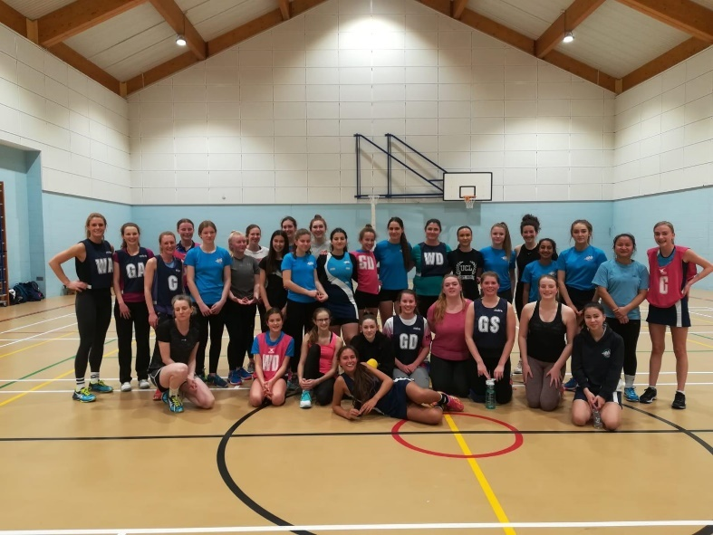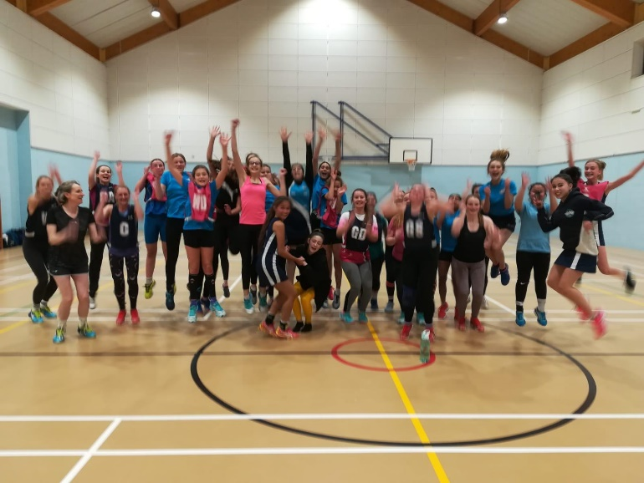

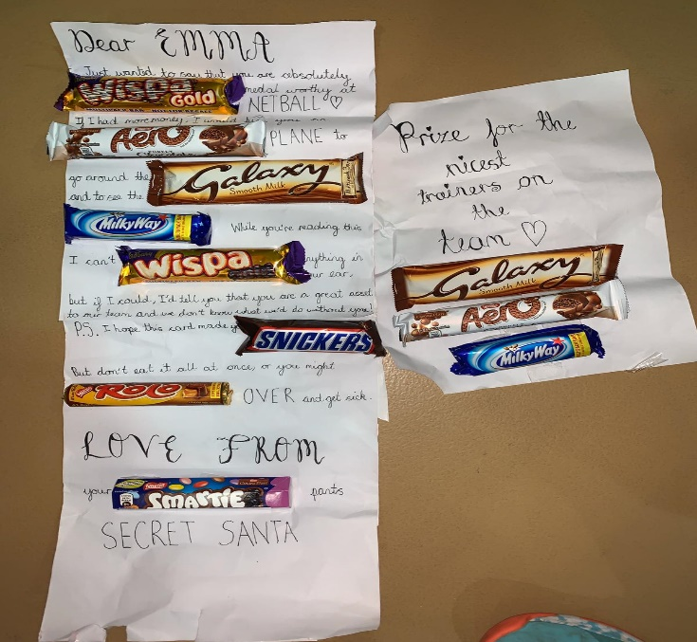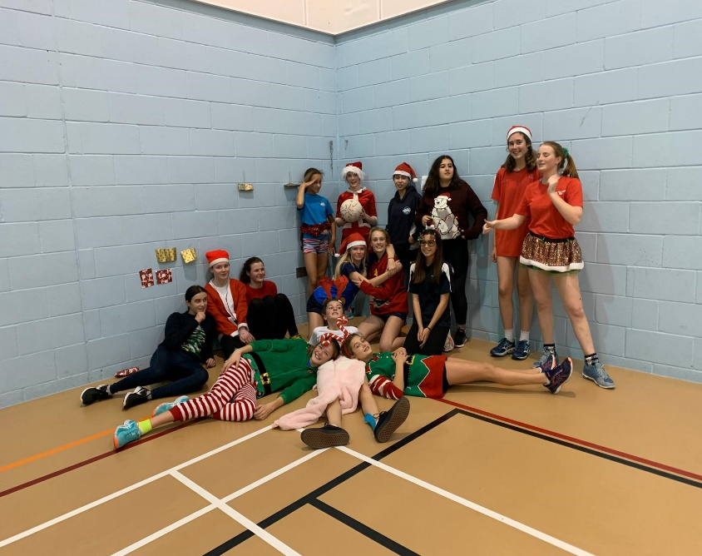

**SENIOR REPORTS**

**ABBEY HURRICANES (Captain – Kirsty Heath)**

Its been a pleasure welcoming returning, new and developing players into the Hurricanes squad, they have all bought invaluable skill to the team, improving the depth of our squad and settling in with ease into the Abbey NC family. Tash and Kate have provided much needed structure to our training sessions, each week has involved tactics and techniques that have often gone on to be integral parts to our game, the rest of the team have shown great willingness to try new things and have committed to utilising lessons learnt on court. Unfortunately, our results haven't gone as planned and we find ourselves in the spot for relegation into Div 2. It is so hard for any team to maintain good morale and commitment when results don't go in your favour. However, I'm so proud to be part of a team that has maintained determination and commitment throughout. We will no doubt come back next season with renewed enthusiasm and keen to do well. Finally, and probably most importantly, we are very grateful for the help we receive from volunteers, Sally, Chris and Sharon in particular have put significant hours in on the bench as our Primary Carer and/or on the officials table, we would not get through the season without them

**Award winners for Hurricanes**

Award winners for Hurricanes

Team Member - Tash Vickers

Most Improved - Helen Werrell

Players player - Claire Hindhaugh

**Nominations**

Cat award - Lizzie Pearce - flies out of nowhere to turn over the ball with cat like speed and agility!

Little Miss Whoops - Kate - probably fallen over the most this season but often down to the opposition!

Little Miss Quick - Helen Werrell - a pocket rocket and unstoppable when shes in her 'flow' 🙂

Club member - Sukey 🙂 because she is a superstar on the comms and we'd all be lost without her 🙂

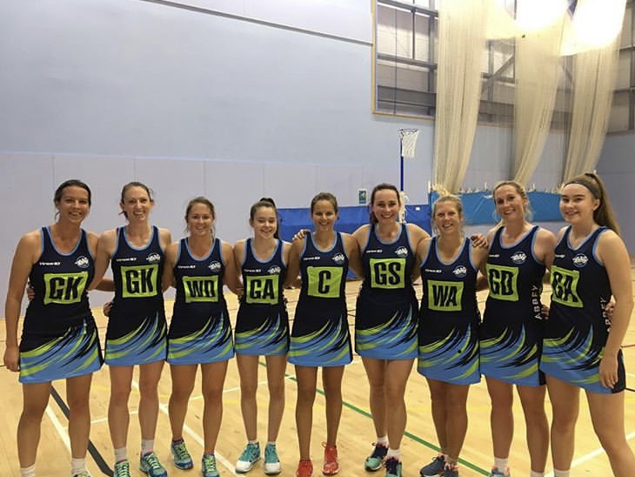

**ABBEY BLIZZARD (Captain – Caitlin Allen & Coach – Sue Lyons)**

**Summary from coach – Sue Lyons**

Blizzard - from new beginnings came great things.

A new team at the start of the season, not only to Prem Plus (with no team members having played there before), but also as a team. Which makes the final position of 2nd (as we would have beaten OSP 😁) in Prem Plus a massive achievement.

I was very proud to support Blizzard this year - and would like to praise all team members for real grit and determination to do well, in what weren't easy circumstances. Brilliant team effort from brilliant players.

**Summary from captain (Caitlen Allen)**

It’s been an absolute pleasure playing for blizzard this year. A team that had many well deserved wins whilst working well together as a team. Thankyou blizzard for making being a captain an easy and enjoyable experience.

**Awards for Blizzard**

Player of the Year: Lizzie Pearce   
Team member of the year: Caitlin Allen   
Most improved player of the year: Joint Grace O’Gorman and Sophie Tyler  
Club member of the year: Tash Vickers

**Nominations**The Cat Award: Ellen s-Clark. Ellen was our sassiest player this year, when she wanted the ball she got that ball and she gave sass while doing so.

Little Miss Whoops- Grace O’Gorman, constantly pulled up for obstruction and contact only down to the fact she gave 100% throughout every match.

Little Miss Quick- Lizzy Pearce. This girl seems to just float around the court, always in the right position at top speed and able to stop and shoot just as fast. Impressive.

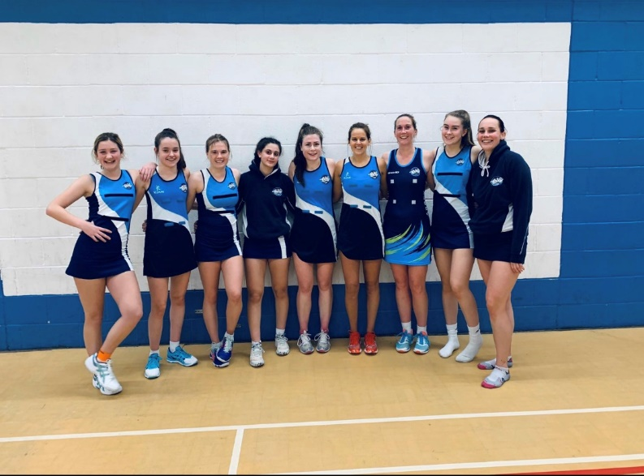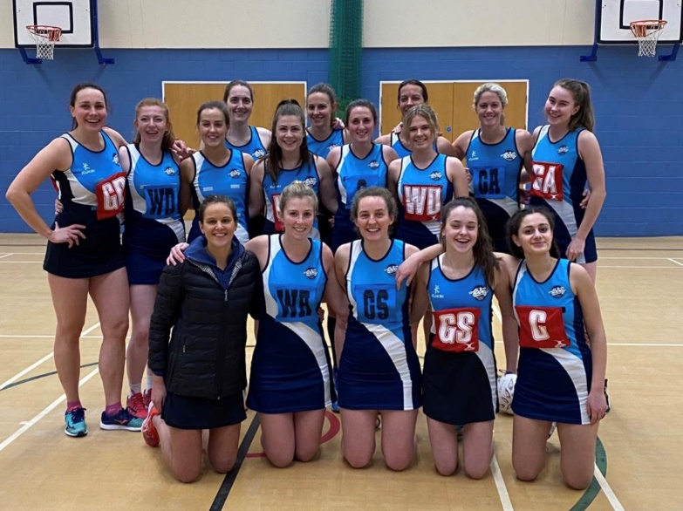

Blizzard Blizzard & Ice

**ABBEY ICE (Captain – Tora Pickup)**

Ice had an enjoyable season and played some brilliant netball. Making the most of a great mix of fantastic new players and valuable old hands we settled in quickly and the first half of our season was looking rosy as we ended up second! The second half of the season included a few frustrating losses, unfortunately we ended up 4th (with two matches left to play). We were very disappointed not to be able to finish our season as planned - with a couple of wins against Trinity to lead us into the summer league! We’ll get them next year!! All in all, lots of fun and brilliant netball - even if we are the dinosaur team!

Special thanks to Tash V, Claire, Sarah, Rama and Sophie for playing for us and making such difference when they did. And we (especially me) really owe a lot to Tash V for her brilliant support both on and off the court.

We’re also very grateful to the Committee for all of their time and work, and especially to everyone who led such great training sessions.

**Ice Awards:**

Player: Tash White (would have been unanimous if she had voted for herself!)

Team member: Tora Pickup (although 5 players were nominated and this shows just how much of a team effort this season was).

Most improved: Showing prowess at both ends - a tied vote for Sukey McMaster and Vicky Knapp.

**Nominations:**

1) Club member of the year - I’d go with Tash Vickers - for all the training and for supporting our team (and me)

2) The cat award (feisty and scrappy for the ball) - I’m assuming this has to be a nomination for our team? - I think Frances as rebounder extraordinaire and seemingly being quite happy to fight with GK or GS as necessary!

3) Little Miss Whoops - and why - Harriet Griffiths-Jones for accidentally kicking a door and breaking her toe... and then playing on it too soon and wondering why she wasn’t able to walk properly the next day...

4) Little Miss Quick - and why - Sarah - super speedy on court, and the quickest of us all, but also for her ability to turn from an amazing shooter into a stellar defender with incredible speed and efficiency!

Photo: embarrassingly I don’t have one that includes everyone, as Frances is missing from this one. But at least everyone else is there and this seems a good reflection of the season.

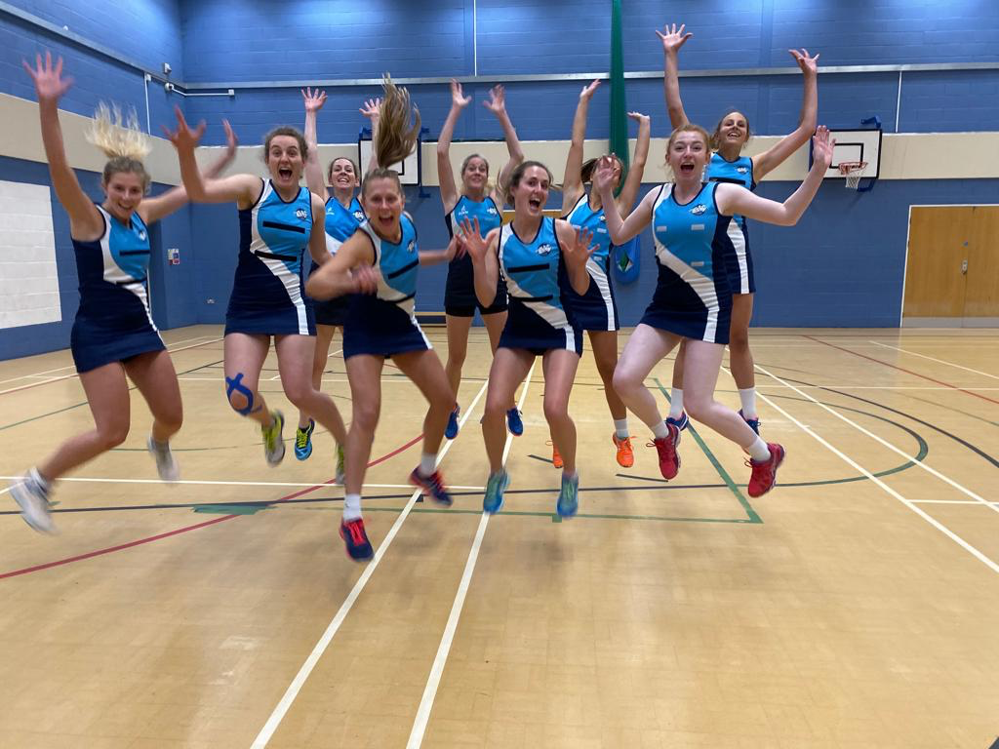

**ABBEY LIGHTNING (Captain – Cath French)**

Lightning were positioned 3rd in Division 1 when matches were halted, with 10 wins and 5 losses from 15 games played. Our performances improved over the course of the season allowing us to climb steadily up the league table. This progress is down to Drew's coaching and encouragement and was also helped by the arrivals of Zahra Jeffries and Kate Mulrey. The highlight of the first half of the season was a 33-32 win against second placed OSP, a match which we won comfortably second time around.

**Note from Chair (Jo Davies) Lightning** – ONL Div 1 had 3 matches left to play (as did all their opposition before the league was prematurely halted). The current standing left them at 3rd however 2nd position was within their reach had all matches been played. Currently Abbey Lightning at 54 points out of 73.

**Awards to Lightning**

Player of the Year – Unanimous - Emily Curtis

Team Member of the Year – Cath French closely followed by Emily Curtis with votes also for Zahra Jeffries

Most improved Player – Won hands down by Hensley Ann Clark, with votes for Emily Curtis and Lauren Davies

**Nominations**

1) Club member of the year - Jo Davies.

2) The cat award (feisty and scrappy for the ball) - We're not really a team of catty players but an opposition coach described Zahra Jeffries as, "fierce but lovely".

3) Little Miss Whoops - Lizzie Storey who has been ill/ injured since Christmas.

4) Little Miss Quick - Kate Mulrey has injected plenty of pace into our attacking third since she joined.

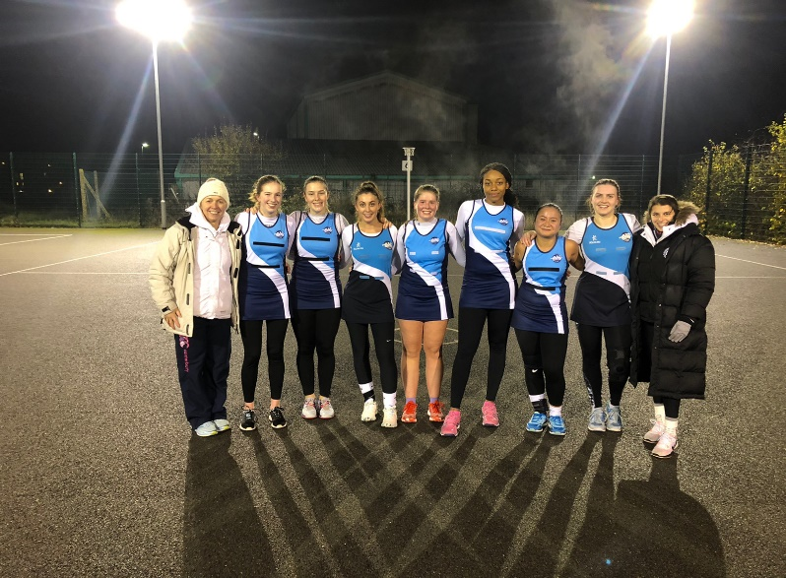

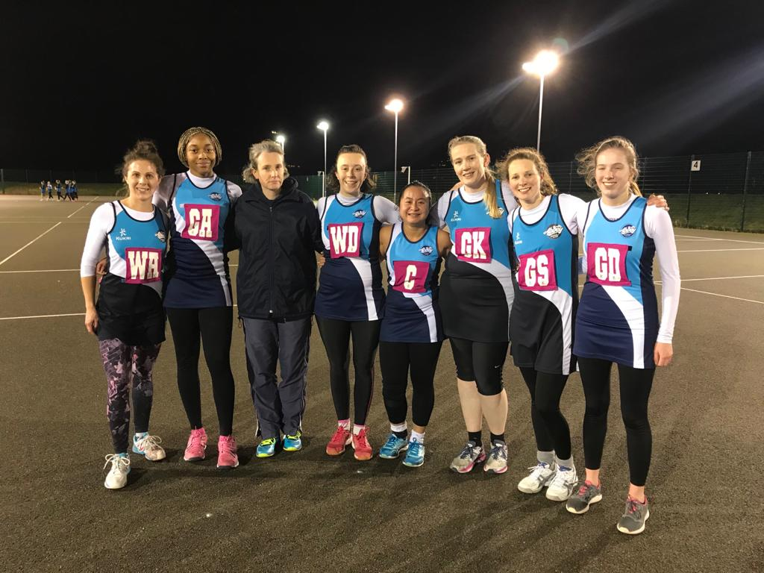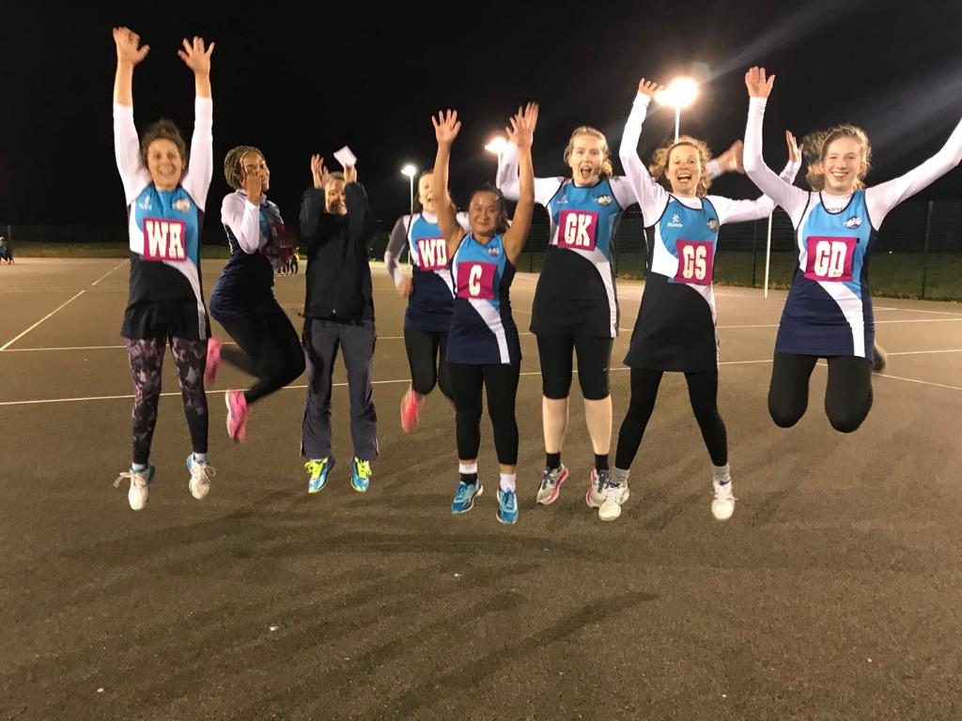

**ABBEY STORM (Captain – Holly Chesser)**

Abbey Storm had a good season overall, due to us being a new team it took us a while to get used to how each other played. The second half of the season was much better, we only lost 2 games and we finished the season in the middle of the table. Towards the end of the season it was obvious that all our hard work at training had paid off. I would like to thank the team for all their hard work and commitment throughout the season making my job as captain easier, we had a lot of fun!

**Note from the Chair – Jo Davies** Storm – ONL Div 3 finished all their games and were placed a commendable 5th position out of 10 teams, 57 points out of 90.

**Awards for Storm**

Player of the year: Izzi Baugh

Team player of the year: Holly Chesser

Most improved: Karis Ball, Sarah Brodie-Brownes, Georgia Mahoney

**Nominations**

1- Club Member Nomination: Zanna Gaydon

2- Little Miss Whoops: embarrassingly me!! If I can vote for myself if not Hannah Toohey

3- Little Miss Quick: Nina Wyniawskj

4- Cat Award: Sophia Lomulo

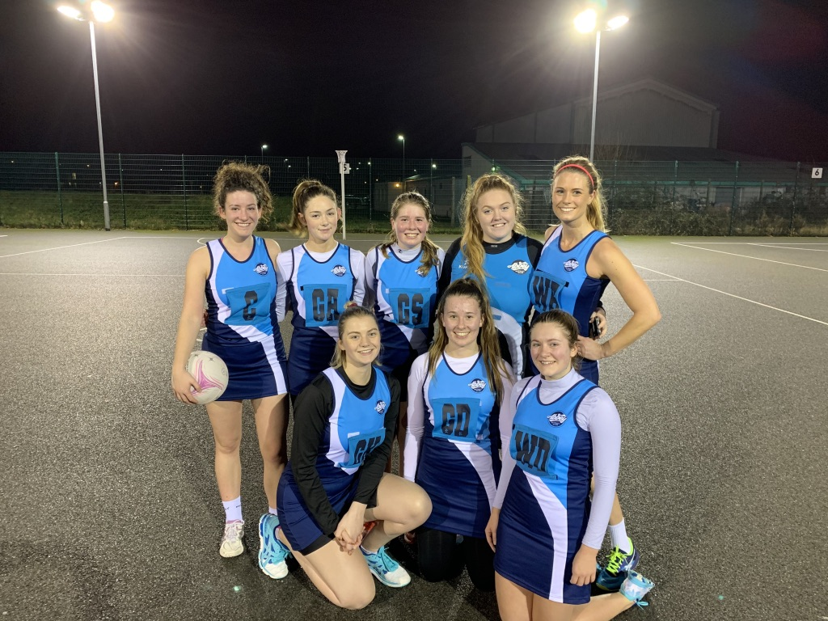

**JUNIOR CO-ORDINATORS REPORT – Jo Pearce**

If ever there was a moment to be grateful for our time together this season it is now! I so wish it had ended with the Versatility Tournaments and the VT training: but it was a genuine relief to have finished the season’s matches in the league.

This year was a first for the OJNL: new committee and new Age Bands. It was also a first for Abbey Juniors: naming the training groups Platinum, Gold, Silver and Bronze as opposed to U17, U15 etc.

It may be prudent to remind parents and girls of the reasoning behind this: as coaches we felt our Abbey Philosophy had become increasingly more centered on the individual player; we were making decisions based as to which leagues and age group girls should play in based on what was best for their development. And whilst this meant for the majority of girls that they trained and played within their age groups, for some in meant playing ‘up’ an age group. These decisions were based on discussions between coaches, but also between players and parents too.

With this in mind, it has been a transitional year for most groups, some being particularly young in their divisions. Despite this, our teams have played brilliantly and produced some fantastic performances and results across the leagues. Well done girls!

Abbey Juniors remain an enormous Club in Oxfordshire. This brings its own challenges with training, court time and squad size and we are continually reviewing the provision we provide and the development we can offer. It is not always easy with this number of girls’ but we are keen not to turn girls away if at all possible. This had to be balanced with striving for success; offering a good standard for ambitious players and those that we feel we can put forward to Satellite; County and ultimately Franchise representation.

We are enormously grateful for the positive support we gain from vast majority of our parents, we cannot coach and run this number of girls, particularly on Sunday matches, without this continued commitment from you- Thank you!

Can I also take this opportunity to thank our brilliant coaches who turn up, regularly stuck in traffic, often after their own full day’s work and juggling their own family commitments to train Abbey girls. Such Volunteers are few and far between and from myself and the rest of the Abbey Committee we are hugely appreciative of the hours, admin and otherwise, that you give to Abbey.

Wishing you all the very best of health, physical and mental wellbeing, over the weeks to come and looking forward to next season…so much!

**ABBEY PLATINUM – Jo Pearce & Kerry Smith**

**Fireflies**

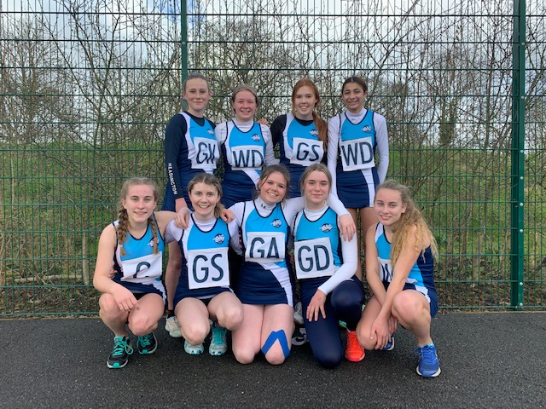

Fireflies finished an impressive 3rd in Division 1. A young squad, with plenty of versatility but also more development to come. Fireflies were also a large squad, which presented some selection challenges but also came into its own in the latter stage of the season when availability waned.

The standard was particularly high in Division 1: Banbury and Wallingford setting the tone and giving Fireflies (and the rest of the division) particularly hard competition. In these matches we need to strive for more consistency as we certainly matched them for parts of the game.

Very close matches, where we were able to pull away in the last quarters or hold off a last minute charge from the opposition, show good determination and resilience in the side. When we stick to task: sensible decision making in our passing and avoiding lateral and flat moves, the ball flowed beautifully down court though our centre-court: Bella showing promise at C. Worth mentioning in particular were our tenacious defence: Ruby, Bessie and Anoushka (ably supported by Karis- thanks Karis!). They created regular problems for the opposition circle and consistently turned ball over all season.

Our last match was an absolute nail-biter against Trinity: Fireflies dug deep and with some great consistent shooting from Paige, we pulled away and then hung onto a 3 goal lead. A great end to the season!

**ABBEY PLATINUM – Fireflies Awards**

Coach’s Player: Lily Taylor

Most Improved: Olivia Sawrey- Cookson

Most Committed: Bessie Chalmers

Player’s Player: Ruby Illsley

**PLATINUM – Bluebirds**

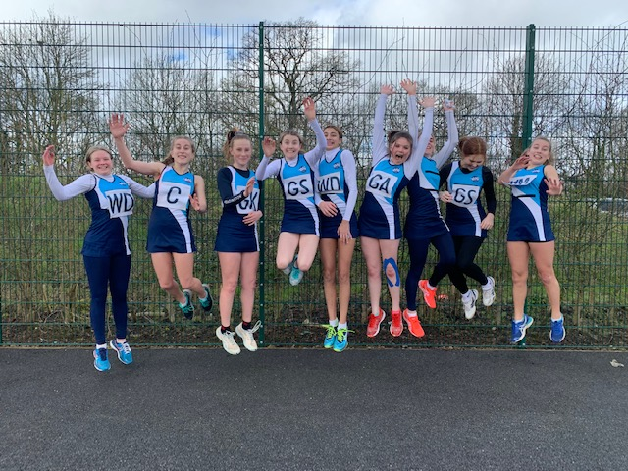

The squad finished second in their league (Division 3) with some fantastic performances over the season., Bluebirds have showed huge improvements in the control of their passing and efficiency of their movement. The girls have worked hard in training, noticeably improving their shooting accuracy and timing of their attacking moves. They more regularly drive towards the ball and are starting to make effective use of square passing to open up the three channels. They have learnt to read off each other in attack, balancing the court well and clearing out to make space. Ella proved to be a great target in the circle and some individuals settled into new positions, (being a somewhat shooter heavy squad!!) developing their versatility. Terris showed her potential at WD and Ana showed promise at WA. Defensive players, including Natalie and Tofunmi, have opened their body position so they can better track the ball better down the court as well as restrict their attackers moves. They became a formidable force and restricted the goals of opposing teams very effectively.

**ABBEY PLATINUM – BLUEBIRDS AWARDS**

Coach’s Player: Ana Sarwar

Most Improved: Natalie Bell

Most Committed: Iona Gibb

Player’s Player: Poppy Harris

County Players:

Oxon- Katie Sawrey-Cookson, Bella Alder & Paige Buffham

Bucks - Bessie Chalmers

**Nomination**

Tiger Award for most tenacious Platinum Player: Ruby Illsley

Caused problems all season for opposition shooters…almost felt sorry for them!

**ABBEY GOLD - Rose Hodgson, Drew Murray-Gill, & Ella Thompson**

WOW what can we say?!

Abbey Gold has had a fantastic season! Dragonflies, Bluebirds and Fireflies have all worked exceptionally hard in training and during matches, showcasing strong commitment and teamwork throughout the season. As coaches all the Gold girls have made us very proud, it’s been a pleasure to work with such intelligent, courteous and skilled young women, both on and off the court. You have really challenged us to plan better and think harder as coaches to get the most out of you – we thank you for that and all your hard work this season!

Well done all, rest up and let’s get ready to smash 2020-2021

**ABBEY GOLD - Dragonflies**

An amazing team and season! Firstly, our Dragonflies stood up and took on the challenge of U17’s division 2!!! Here they really made their mark, narrowly missing out on 3rd place (and even really 2nd place) with some incredible wins, using their creativeness on court and absolute team spirit each week. The Dragonflies have been committed to the game and to their team week in week out, and this evidently helped as the games became tighter and the girl’s passion grew as the season went on. We have been very impressed with the development of Dragonflies’ units of shooters, centre courts and defenders, gaining more consistency to work together to turn over the ball and bring it down court to ultimately score! They have worked hard together to learn how to apply pressure and make centre passes and turnovers more effective in both attack and defence, showing brilliant confidence and skill! Well done Dragonflies, you have all individually brought passion, talent and often sassiness to create a fantastic team and season to remember!

Players’ Player – Romilly Middlemiss

Coaches’ player –  Bea Gelling

Most improved – Honey Valdiserri

Most Committed – Katie Lackenby

**ABBEY GOLD - Fireflies**

 A brilliant (but difficult!!) season, but hey you all needed that challenge! At the start of the season, the fireflies team was made up of players with a lot of individual talent. By the end, we could see a strong team unit shining through! What a challenge to go into the top division (and for many, up an age group!)! You all stood tall, put 110% into each game to make each one highly contested and a pleasure to watch, to finally come 4th in a very demanding league, something you should be very proud of. The fireflies have come on leaps and bounds from basic use of space down the court to starting to communicate better and use set plays against teams, something we have been very impressed by! It’s been an absolute pleasure working with such a highly skilled team and as coaches very excited to see what we can bring to the league next season!! Let’s go for the win!!!

Players’ Player – Harriet Preston

Coaches’ player – Megan Jacobs

Most improved – Sophia Oppon

Most Committed – Leila May

**Abbey Gold’s Tiger’s award nominee:**

Imogen Watson-Sinclair – for her terrier-like tenacity, persistence and sassiness on and off the ball.

**ABBEY GOLD - Bluebirds**

Champions!!!!  What a great season for Bluebirds, winning every match and standing tall at the top of table clear by 8 points! The girls never stopped fighting, even though sometimes it may have taken three quarters to get there!!! Each of the Bluebirds have shown how much they’ve improved from the start to finish of the season both as team players, player units, and also as individuals, making us very proud. Bluebirds have been amazing at taking feedback and coaching at training and at matches, using this to grow in confidence and make the right decisions on court. As coaches we have been impressed by Bluebirds’ brilliant use of space throughout the court, fantastic teamwork and communication, which has made them start stronger in every match as a team unit. We can’t wait to develop on what the girls have learnt from this season and hope their commitment, passion and concentration remains the same. Well done Bluebirds you fully deserved to win the league!!

Players’ Player – Shaan Bhomra

Coaches’ player – Charlotte Rothery

Most improved – Faith Woodruffe-Peacock

Most Committed – Dora Grandy

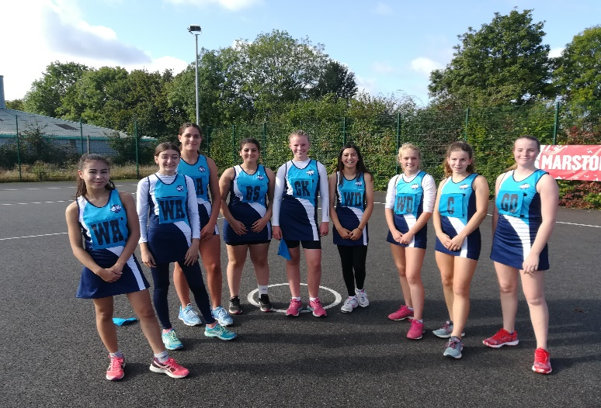 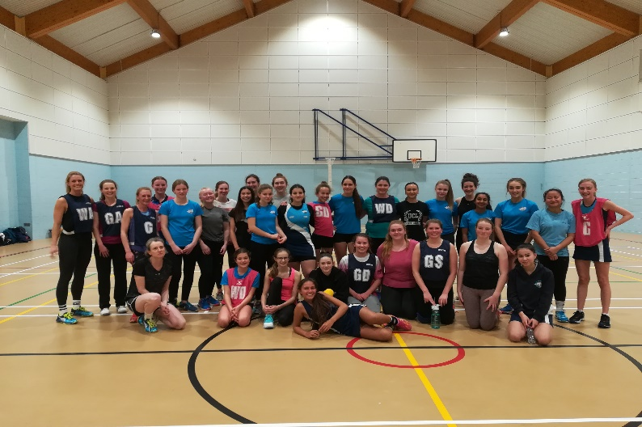

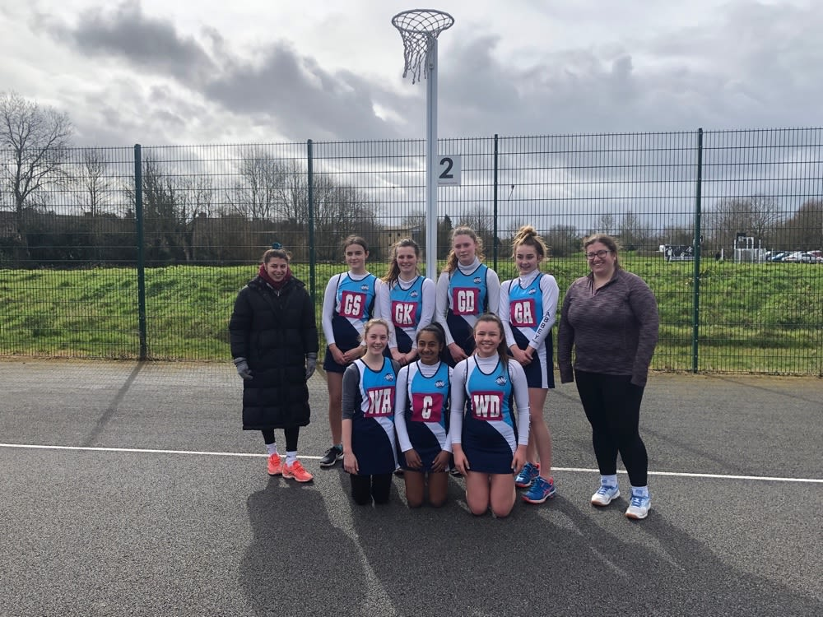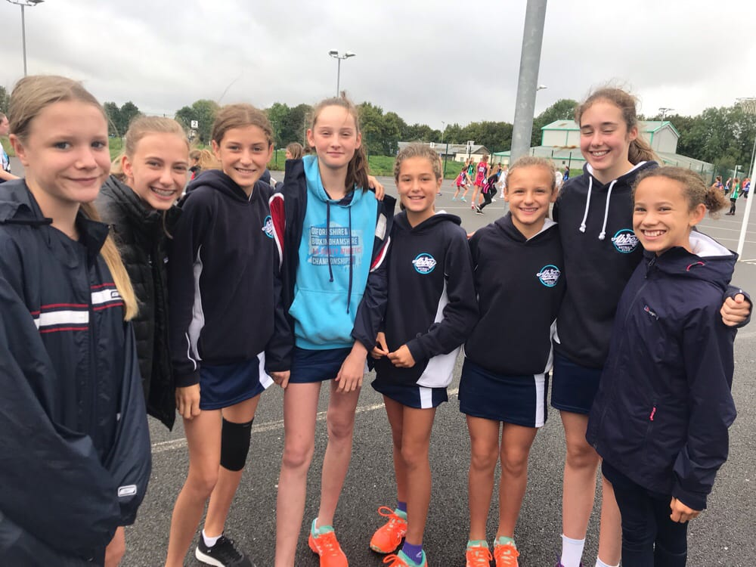

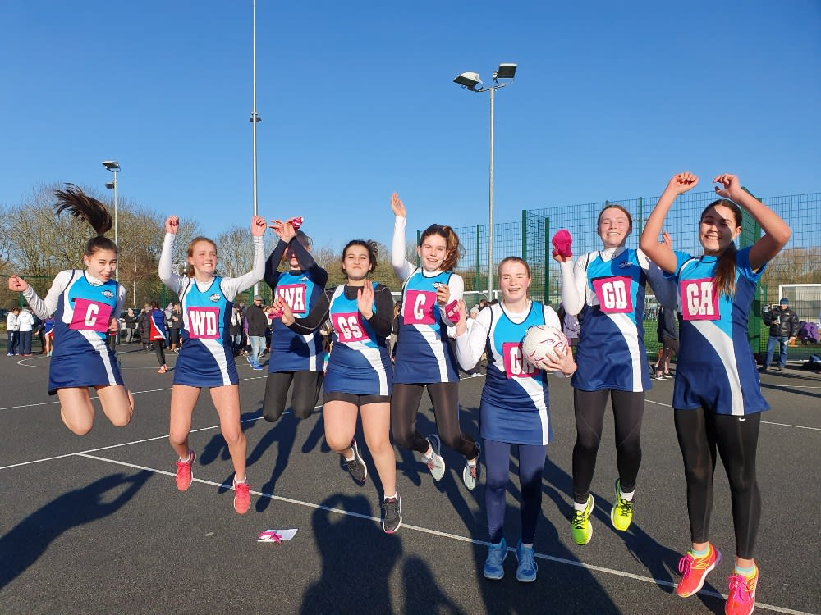

**U11 & U13’s**

**BRONZE - Sue Lyons**

This year with so many keen youngsters wanting to play netball we introduced two Bronze groups, both training bi-weekly and with one gaining some match play across the season. Splitting the girls across the two groups was difficult, as they are all still quite inexperienced when joining Abbey, so we ensured that throughout the season there was flexibility to move a player from one group to the other, as their skills improved. 3 girls moved to the match play squad this season, fitting in seamlessly when they joined. So many of the girls made great progress this season – ready for the challenge of match play next season.

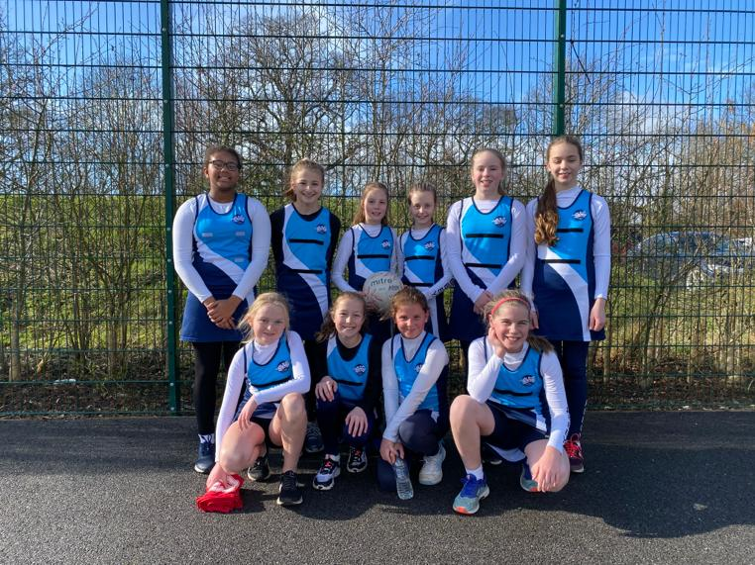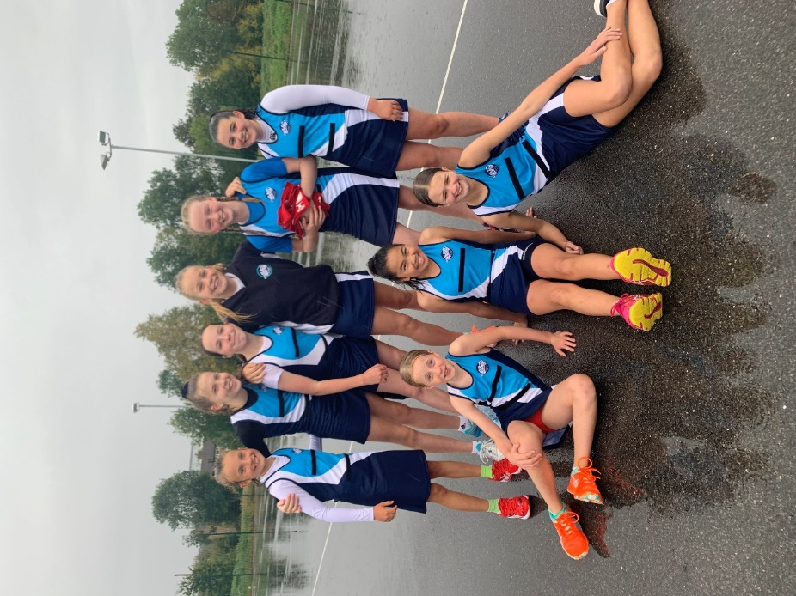With 24 girls in the match play group I was constantly challenged with rotating the girls to ensure they all gained Oxfordshire League experience. This resulted in very large squads on a Sunday morning as I juggled availability, experience and exposure to very tough competition week-on-week. However, every Sunday, without fail, the girls pulled out the stops. I have never coached a group of girls as enthusiastic and determined as our Dragonflies group has been this year – plus, they were always smiling! Also, I have never received as many compliments from fellow coaches and umpires about the endeavour of a team. Finishing 4th in Division 3 was no mean feat for such a young and inexperienced group (against much older and taller competition) – so a huge well done from me!

Some individual highlights to note: Freya H, Ruthie and Chrissy were all selected to train with Team Matrix U10s; and Clara and Aisha were invited to trial for the U11s.

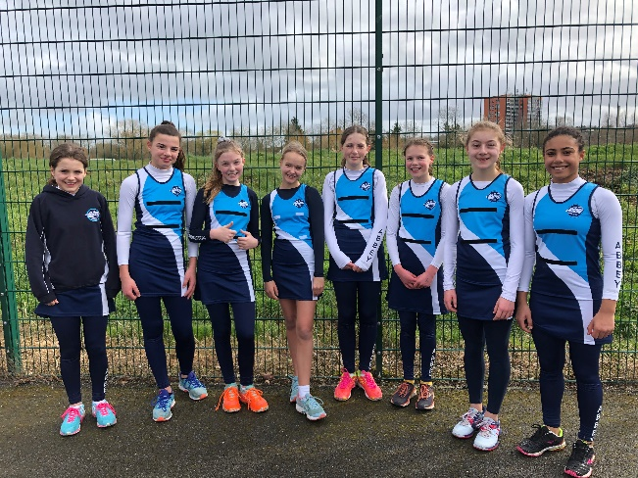  
**SILVER - Coached by Kate Ricks and Sue Lyons**

With the Oxfordshire League using a ‘seeding system’ to place teams in divisions, the girls did very well to ensure we had one team in Division 1 and one in Division 2. However, then the challenge really started with both teams having to work exceptionally hard each week against tough competition. Half way through the season, we really turned a corner with both teams starting to gel and deliver some great performances - and leaving the best to the last matches. Bluebirds beat Trinity Lynxes (who they were drawing with) to end 3rd in Division 2 and Fireflies beat Faringdon Thunder - with a 25 goal-difference - to finish 3rd in Division 1 – an excellent final result from both teams.

Some individual achievements to note: Bella was selected for Team Matrix U11s and Emma P has been asked to trial, and Harriet has been called back for an U12s trial. Plus, Izzy has been selected for the Oxfordshire Satellite group.

**BRONZE - Award Winners**

**Fireflies**

Players’ Player: ​Evie Pearce

Most committed: Harriet Haynes

Most improved: Izzy Adams

Coaches’ award: Lola Allen

**Bluebirds**

Players’ Player: Sarah Blackstock Grillo

Most committed: Isobel Boulter

Most improved: Emma Park

Coaches’ award: Milly Weaver

 ​

**Dragonflies**

Players’ Player: Aisha Justilien

Most committed: Zahra Cheema

Most improved: Clara Walker

Coach’s award: Alexandra Miller

**Bronze B**

Most committed: Natasha Davis

Most improved: Emma Lee

Coach’s award: Chrissy Coney

**ELECTION OF OFFICERS FOR 2020-2021**

**Committee**

Chair – Jo Davies

Vice Chair – Kate Ricks

Treasurer – Mike Buffham

Correspondence Sec – Sukey McMaster

Umpiring Secretary – Jo Davies

Coaching Secretary – Tash Vickers

Junior Co-ordinator – Jo Pearce

Kit Manager and equipment co-ordinator – Helen Lamprell

Publicity Secretary – Kirsty Heath

Social Secretary – Rose Hodgson

Social Media Secretary – Lauren Davies

Volunteer Co-ordinator – Gemma Muttitt

Safeguarding and CAPS Co-ordinator – Lesley Williams

Bookings Secretary – Becky Mailen

**Summary**

Well thank you for getting this far and reading all the reports! As you can see a lot of hard work, motivation, competitiveness, good morale, enthusiasm, friendships, teamwork and character building is encouraged at Abbey Netball Club. We hope we can get back to playing netball in the not too distant future and rekindle the good work that has been put into Abbey this season by the Committee and since the early 1970’s when it all began.

Attached is the full list of Award Winners and our Helpers. Again, thank you to everyone who has contributed to helping Abbey in some way or other.

In the meantime, keep well, keep safe and be netball ready for the new season. We will advise you as soon as it is safe to resume to our training.

Edited by Jo Davies (Abbey Chair) & Sukey McMaster (Correspondence Sec)

Ref: Abbey AGM 2020 Chairs Summary Report

Att: Finance Report

Award Winners & Helpers



